UAT Plan

for

MoveWatch

Jade Huang

Index

1. Scope 3

1.1. Objectives and business requirements 3

1.2. Scope 3

2. Testing team 4

3. Environmental requirements 5

3.1. Hardware requirements 5

3.2. Software requirements 5

4. Test Scripts 6

# Scope

## Objectives and business requirements

The goal of this user acceptance test is to ensure that the MoveWatch can encourage Michelle to be less sedentary as designed. We will measure success by how much of the test script is successfully carried out.

## Scope

The MoveWatch has not been tested so we need to ensure it is functioning as intended before allowing the patient to use it. I have shortened the times for easier testing.

For this UAT test, we’d like to test if:

* The watch correctly displays “Get Active!” on the screen after each minute of sedentary behaviour
* The watch fills one bar of the health bar every time the tester has walked 10 steps
* The tester’s number of steps out of 70 display on the LED screen

For the UAT test, we are not testing:

* What the watch will do if the tester does not walk 10 steps
* What happens if the tester walks over 70 steps

## System Diagrams

In this section, paste any drawings or diagrams that help the UAT team understand the program being tested. With each drawing include a brief explanation of how the drawing represents the application or system being tested.

**Flowchart (below):**

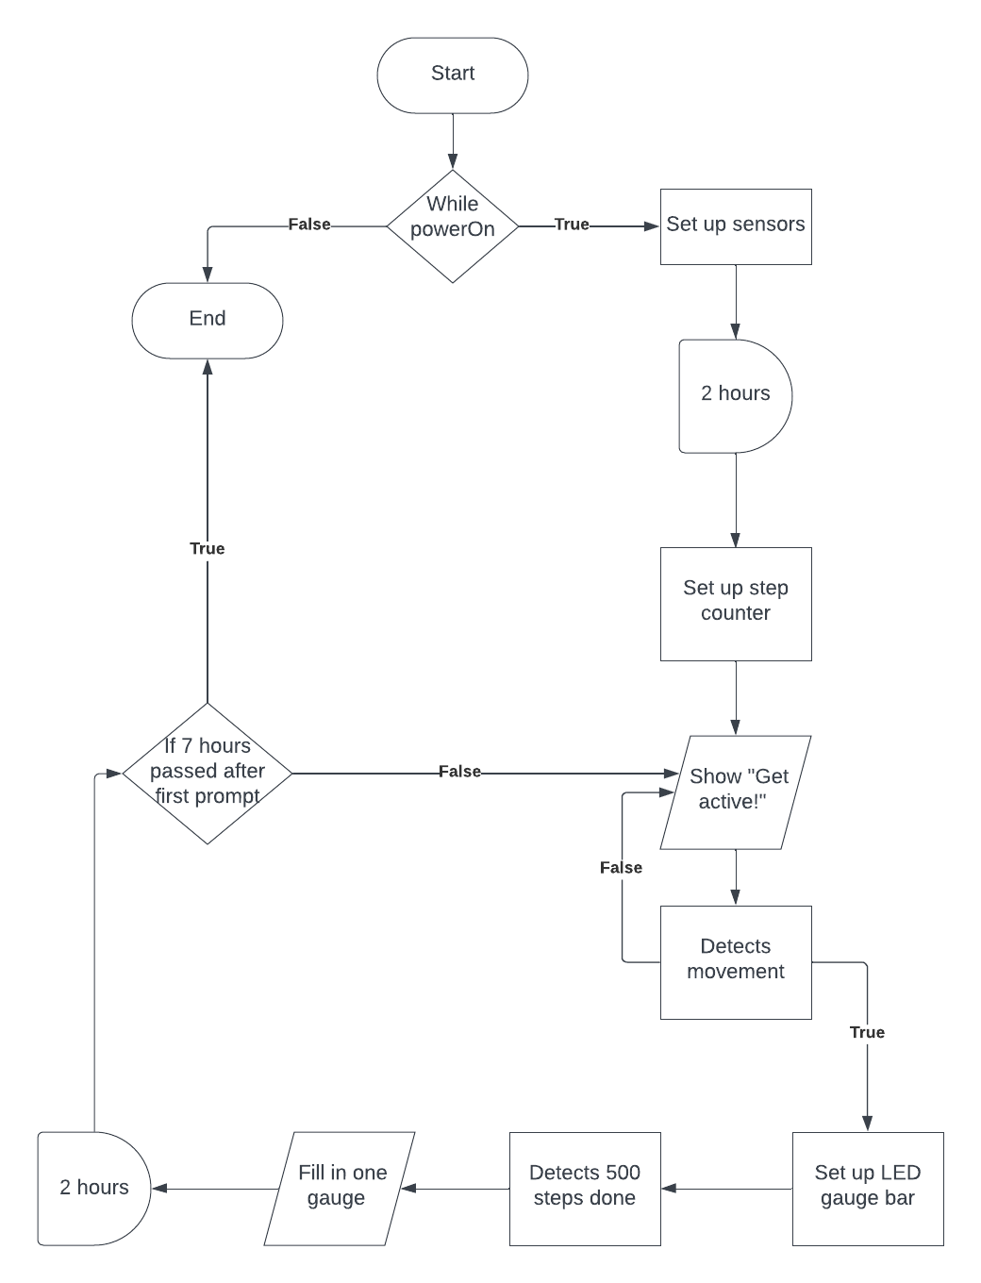

The flowchart shows the flow of logic for the device. It shows the process the watch goes through when it starts.

**High-level concept pictorial:**

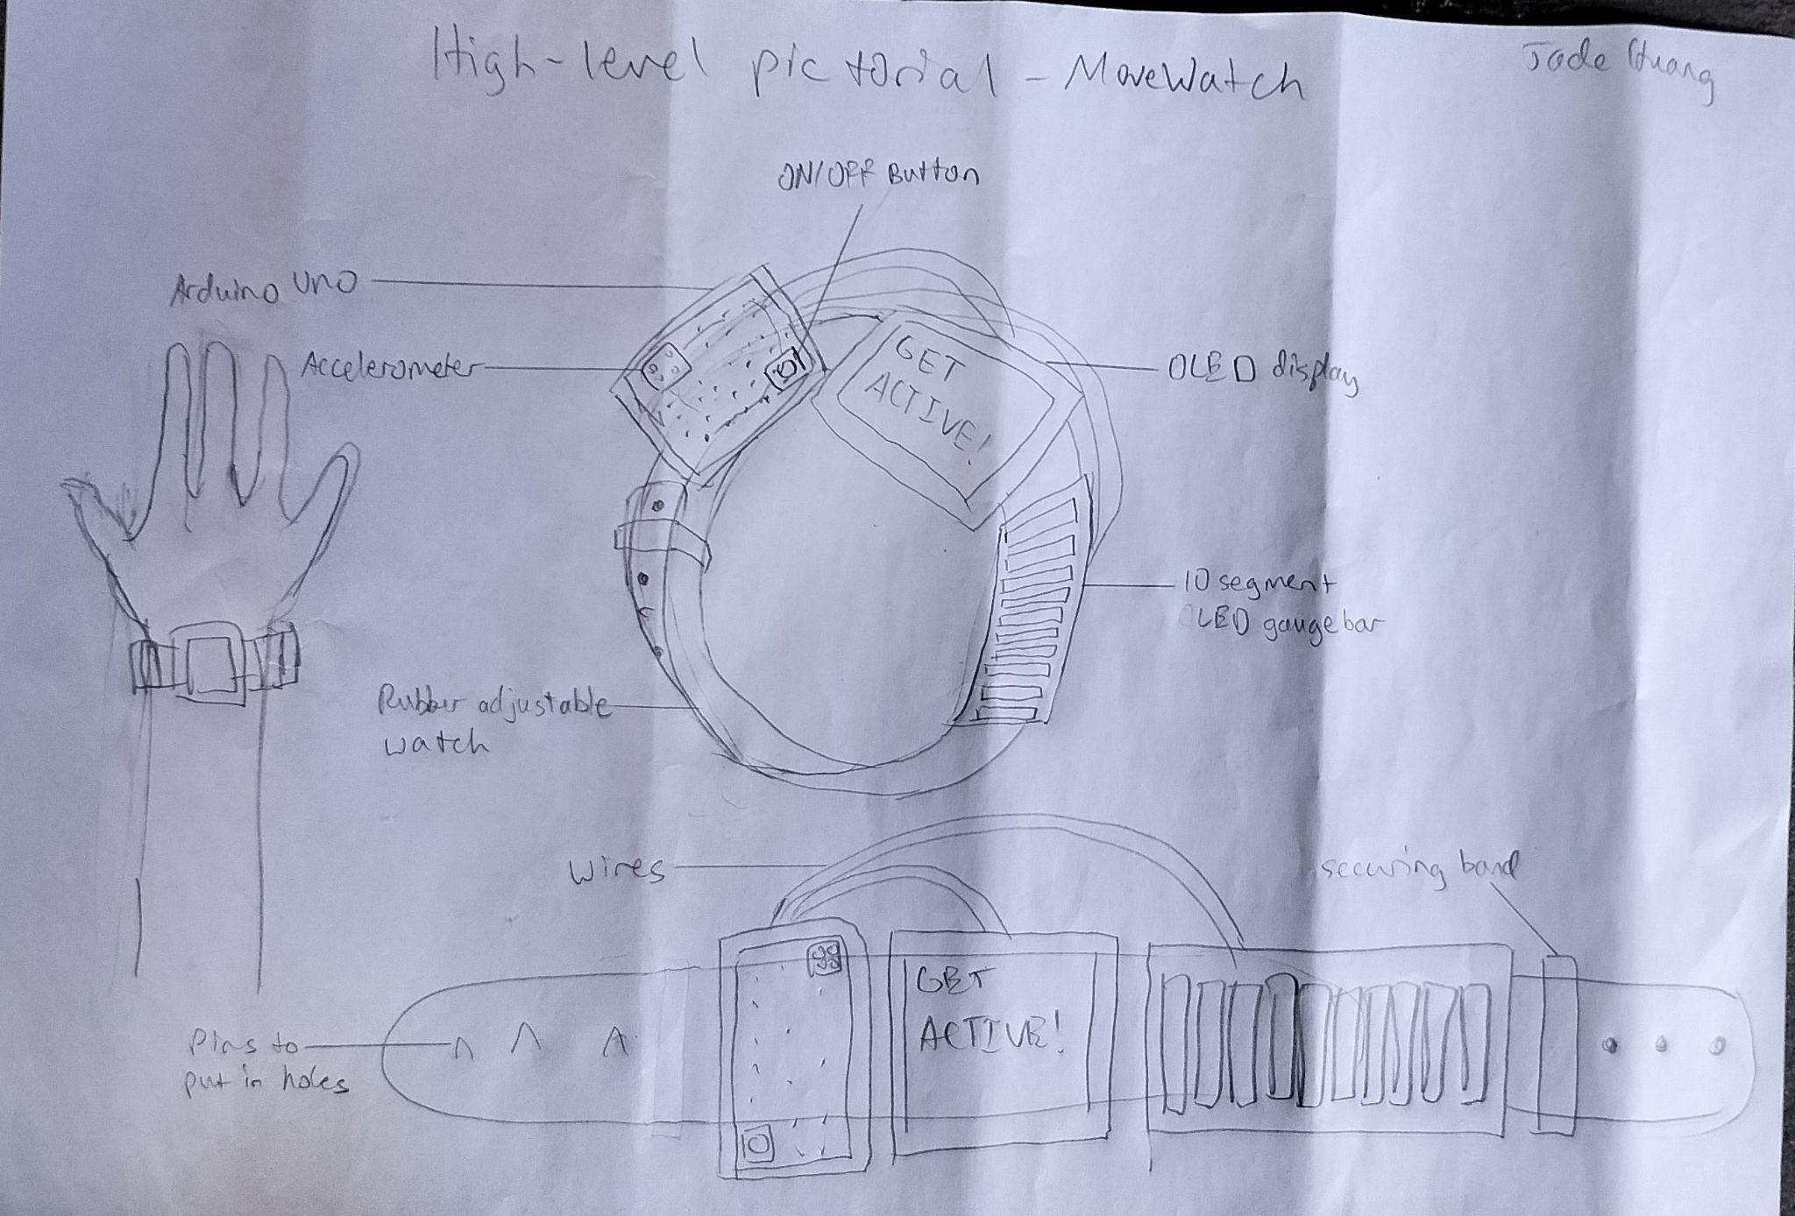

The pictorial shows labelled parts of the watch which helps the user know what the test script is referring to.

# Testing team

| **Name** | **Responsibilities** |
| --- | --- |
| Jade Huang | UAT Coordinator, creates report of data |
| Darlene Purnomo | Carries out test scripts |

# Environmental requirements

## Hardware requirements

* Arduino Uno
* HP laptop
* Wearer’s arm

## Software requirements

Arduino IDE

## Network requirements

Wifi

# Test Scripts

| **Test** | **Describe the feature being tested** | **Describe the user input or test data** | **Describe the pass criteria** |  |
| --- | --- | --- | --- | --- |
| 1.1 | Display of “Get Active! message | 1. User sits down for a minute 2. User observes OLED display 3. Repeat seven times | User sees the message “Get Active!” every time they observe the watch | Tester name: Darlene Purnomo   |  | PASS | | --- | --- | |  | FAIL |   Observations: |
| 1.2 | Health bar fills | 1. User walks 10 steps 2. User observes health bar | User sees one bar filled | Tester name: Darlene Purnomo   |  | PASS | | --- | --- | |  | FAIL |   Observations: |
| 1.3 | Step count displays | 1. User walks 10 steps  2. User observes OLED display | User sees “step count/70” on the OLED display | Tester name: Darlene Purnomo   |  | PASS | | --- | --- | |  | FAIL |   Observations: |